**How does life differ for Palestinians and Israelis inside Israel?**

**Lesson 18**

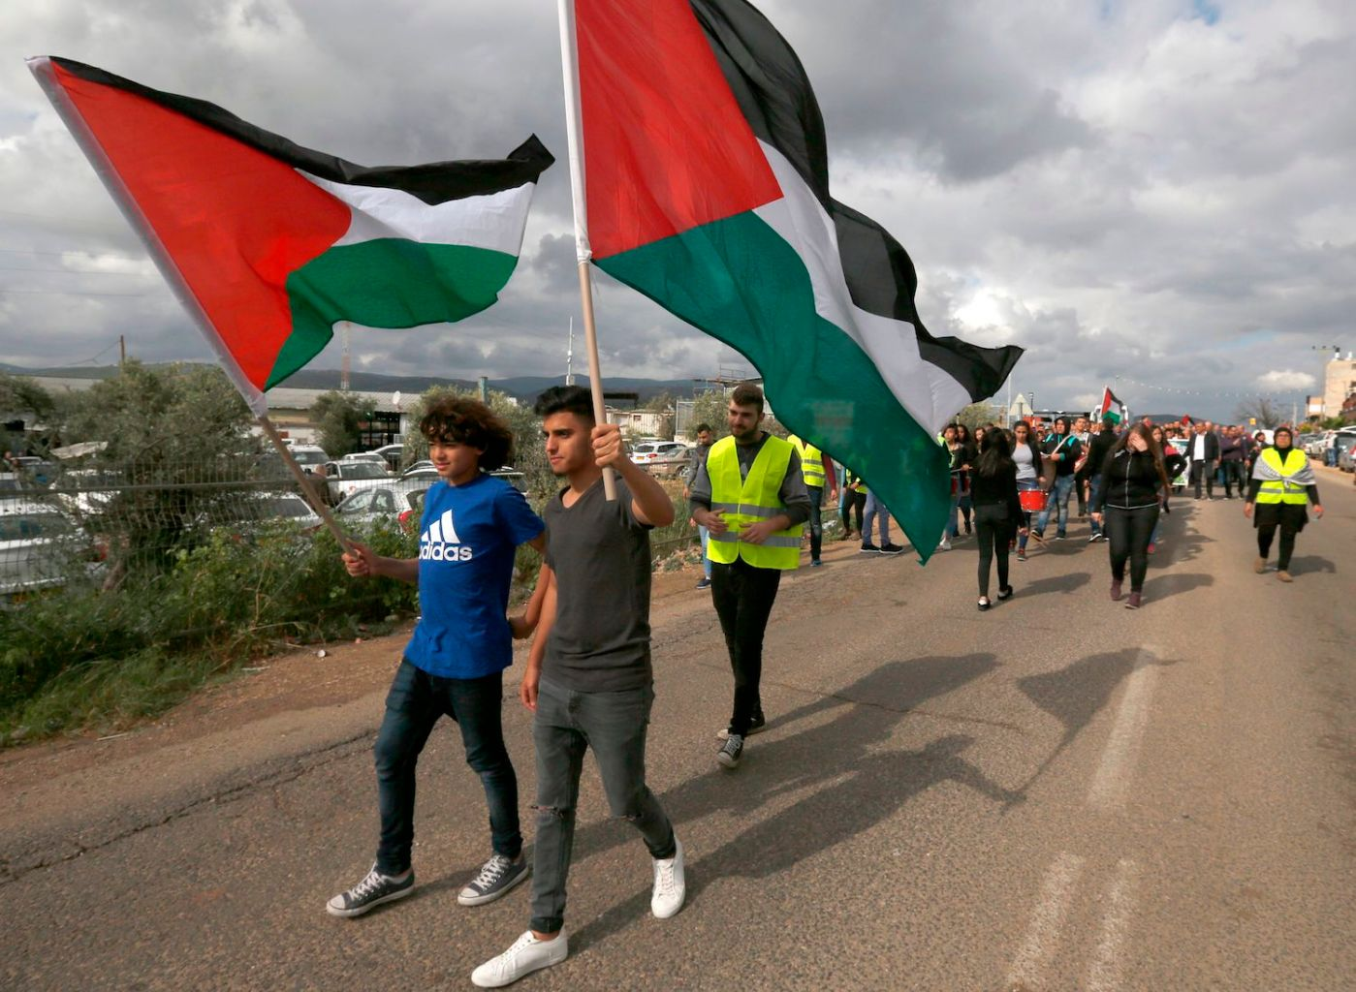

**By the end of this lesson, you should be able to:**

Describe the population of Israel

Explain why some Palestinians live in Israel

Explain how life differs for Palestinians and Israelis inside Israel

**Keywords**

Green Line

Israeli Arab

Discrimination

Apartheid

**Keywords wordsearch**

Green Line

Israeli Arab

Discrimination

Apartheid

**Question**

Have you come across any of today’s keywords before? If so, where?

**What do we mean by Israel?**

Since the early 1900s, the map of Palestine-Israel has shifted, as we have seen in previous lessons:

Haifa is an example of a place in Israel with a mixed Palestinian and Israeli population

1.Can you locate Haifa on these maps?

2.Historically, has Haifa been in Palestine or Israel?

**A short history of Palestine-Israel up to the present: summary**

Before 1918, all of Palestine-Israel was part of the **Ottoman Empire.** This was a large empire that spanned from South-eastern Europe and Western Asia to North Africa

In 1914, the First World War began. The Ottoman Empire joined the First World War on the side of the Central powers including Germany. This meant that when the Central powers were defeated in 1918, there was no obvious government to govern the land that used to be the Ottoman Empire, including Palestine-Israel

The newly-formed League of Nations discussed the problem and came up with the idea of the **Mandates system**. This was the idea that the territories of the former Ottoman Empire, including Palestine-Israel, would be governed by the victorious powers of WWI until they were considered ready to govern themselves. So **Palestine-Israel became a British Mandate**

The Mandates were meant to be fairer than colonies because the governing power was responsible to the League of Nations, an international organisation created after the First World War with the primary aim of avoiding another world war

However, the British Mandate for Palestine **didn’t go to plan**. In fact, it was a **disaster**. Britain had made contradictory promises to the Palestinians who lived there and to the Jews

In 1948, Britain left Palestine-Israel and the **Nakba** (Arabic for ‘catastrophe’) occurred. This involved large-scale attacks by Zionists aimed at expelling Palestinians from their towns and villages to build a future Jewish state in Palestine-Israel. It is an example of ethnic cleansing: the systematic forced removal of an ethnic, racial or religious group (the Palestinians) from a particular area (Palestine)

Eventually it was decided that Egypt would govern **Gaza** and the **West Bank** would be governed by Jordan

Tensions between Israelis who lived in the new state of Israel and Palestinians (750,000 of whom had lost their homes during the Nakba) were **extremely high** in the years that followed

Most importantly, **in 1967 Israeli occupied** (invaded and took control of) **Gaza and the West Bank.** Israel also **illegally annexed East Jerusalem in 1980**

*This is why we talk about the occupied Palestinian territories of the West Bank and Gaza today. Palestinians are still living under Israeli occupation!*

**Map of Palestine-Israel today**

**The population of Israel**

Today, 9 million people live in Israel. 80% are Israeli and 20% are Palestinian

Some Palestinians live in Israelbecause **before 1948, what we now call Israel was all Palestine.** In the Nakba of 1948, 750,000 Palestinians were forced to leave their homes, but some Palestinians remained in the new state of Israel

The Palestinians who live in Israel are sometimes referred to as “Israeli Arabs”, but many do not like this as it **denies their Palestinian identity and separates Palestinian and Arab identity**

**Question**

What can you remember about the Nakba? What was it and when did it happen?

**The Nakba**

The Nakba was an example of **ethnic cleansing**: the systematic forced removal of an ethnic, racial or religious group (the Palestinians) from a particular area (Palestine)

It involved **large-scale attacks** aimed at **expelling Palestinians** from their towns and villages to build a future Jewish state

**530** Palestinian villages and cities were destroyed

**15,000** Palestinians were killed in a series of mass atrocities, including **over 70 massacres**

**750,000** Palestinians (half of the Palestinian population) were forced to leave their homes and became **refugees**

**Palestinians in Israel**

Discrimination: *the unfair treatment of someone based on their race, age or another characteristic*

What are some examples of discrimination?

Under Israeli policies, Palestinians living in Israel live separate lives to Israelis. They are treated legally, politically, economically and socially as **second-class citizens**

Israel maintains **over** **65 laws** that discriminate against Palestinians

Since 2018, Arabic has been removed as an **official language** of Israel

Palestinians in Israel have poor access to **education, jobs and services**. They face discrimination in all of these areas, including **health**. This is a very real problem. Palestinians make up **20%** of the population of Israel, but they only receive **1.7%** of the budget for local councils

Palestinians also face significant disadvantages when it comes to **housing, construction and land development**

This makes life for Palestinians in Israel very difficult

**Activity**

Use this information to create a spider diagram of **life for Palestinians in Israel.** Consider grouping the information into themes, for example ‘legal’, ‘economic’ & ‘social’ aspects of life

**Question**

How would it feel to be Palestinian in Israel?

Has anything surprised you?

**Apartheid**

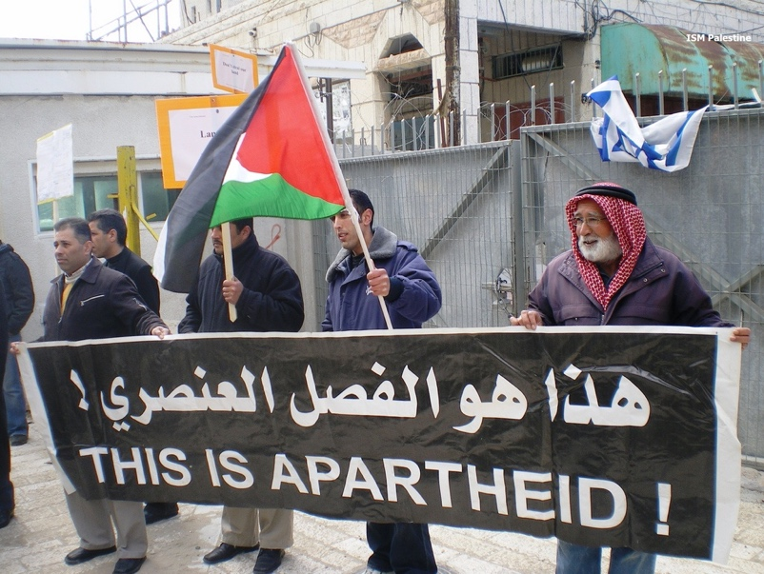

Apartheid: *a policy or system of separation based on race*

Apartheid is usually associated with discrimination in South Africa but it is also used to describe Israeli policy towards Palestinians

In 2021, international NGO Human Rights Watch and Israeli NGO B’Tselem said that Israel is committing the crime of apartheid

**Exam-style question**

Explain two consequences of being Palestinian and living in Israel [8 marks]

**Questions**

1.Describe the population of Israel

2.Why do some Palestinians live in Israel?

3. How does life differ for Palestinians and Israelis inside Israel?